1. Indicate whether each of the following applies to CISC or RISC by placing either a C (for CISC) or an R (for RISC) in the blank.

_____ 1. Simple instructions averaging 1 clock cycle to execute

_____ 2. Single register set

_____ 3. Complexity is in the compiler

_____ 4. Highly pipelined

Ans R,C,R,R

2. A RISC processor has 8 global registers and 10 register windows. Each window has 4 input registers, 8 local and 4 output. How many total registers are in this CPU? (HINT:

Remember, due to the circular nature of the windows, the output registers of the last

window are shared as the input registers of the first window.)

*Ans.*

(8 + 4) * 10 = 120 + 8 = 128

3. A RISC processor has 152 total registers, with 12 designated as global registers. The 10 register windows each have 6 input registers and 6 output registers. How many local registers are in each register window set?

Ans.

8

4. How are SIMD and MIMD similar? How are they different? Note, you are not to define the terms, but instead compare the models.

*Ans.*

Both SIMD and MIMD machines have multiple processors and can operate on different

pieces of data in parallel. However, in SIMD, all processors must execute the same

instruction at the same time, while in MIMD, each processor can execute a different

instruction.

5. Given the following Omega network, which allows 8 CPUs (P0 through P7) to access 8 memory modules (M0 through M7):

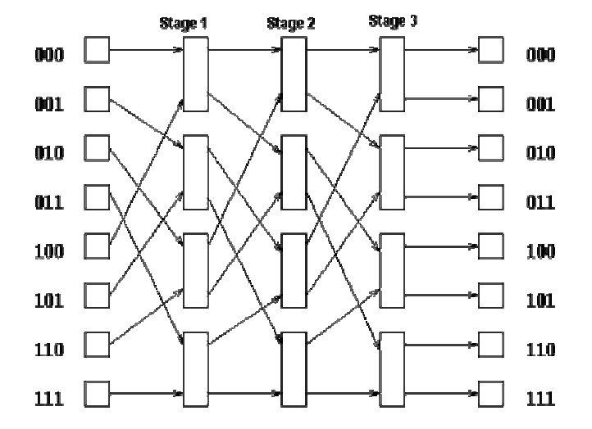



a. Show the following connections through the network:

i) P0 🡪 M2

ii) P4 🡪 M4

iii) P6 🡪 M3

b. Can these connections occur simultaneously or do they conflict? Explain.

c. List a processor-to-memory access that conflicts (is blocked) by the access P0 M2 that is not listed in part (a).

d. List a processor-to-memory access that is not blocked by the access P0 M2 and is not listed in part (a).

*Ans.*

a. for P0 🡪 M2 beginning p0 (0 00) (path no. switch no.) 🡪 M2 (010) switch 1 out at 0 switch 2 out at 1 and switch 3 out at 0)

b. No, there is a conflict between P0 M2 and P6 M3 in switch 3B.

c. Any access requiring switch 1A to be cross, 2A to be through, or 3B to be cross.



d. Any access NOT requiring 1A, 2A, or 3B, or those utilizing 1A through, 2A cross, or 3B through.

6. For what type of program-level parallelism (data or control) is SIMD best suited? For what type of program-level parallelism is MIMD best suited?

Ans.

SIMD is best suited for data parallelism; MIMD is best suited for control or task parallelism.

7. Why are distributed systems desirable?

Ans.

Distributed systems allow for resource sharing (such as sharing of printers and files), and thus can reduce system cost. They also allow for redundancy, which increases reliability (if one site fails, the remaining sites can still function). These systems also speed up computation, as jobs can be distributed and run concurrently at many sites. Lastly, distributed systems run programs that, due to the nature of the system, can share data with other systems more easily via the communications network and communicate with remote sites.

8. Flynn's taxonomy consists of four primary models of computation. Briefly describe each of the categories and give an example of a high-level problem for which each of these models

might be used.

*Ans.*

SISD, or single instruction, single data stream, is the typical von Neumann architecture.

Standard uniprocessors are examples of SISD machines. Word processing and normal,

everyday activities for most users would be well suited to this model. SIMD, or single

instruction, multiple data steam, executes one specific instruction on many pieces of data.

This model is very useful in matrix operations. MISD, multiple

instructions, single data, is not very useful, so no examples will be given. MIMD, multiple

instructions, multiple data, consists of multiprocessors and most current parallel systems.